NISM Series XIX-B: Alternative Investment Funds (Category III) Distributors
Mode of Delivery: Online Live Interactive + Online Self-paced*
Duration: 24 Hours
Study Materials: Recording available of online live sessions, PPTs (600+ Slides), 600+ MCQs, 20+ case studies and PDFs.
The NISM Series XIX-B Certification Examination sets a standardized knowledge benchmark for individuals working as distributors or placement agents in the domain of Alternative Investment Funds (AIFs), focusing exclusively on Category III AIFs.
This voluntary certification aims to enhance the quality of sales and distribution practices and improve investor servicing standards.

Upon successful completion of the examination, candidates will:
• Understand Alternative Investments:
Grasp the fundamentals of alternative asset classes and the functioning of the Category III AIF market in India.
• Comprehend the Ecosystem and Risk Management Role of Category III AIFs:
Learn about fund structure, external service providers, and the application of Category III AIFs as risk management tools.
• Master Performance Evaluation and Valuation Techniques:
Develop skills in interpreting performance metrics, benchmarking, and NAV computation for Category III AIFs.
• Understand Taxation and Regulatory Frameworks:
Gain knowledge about taxation principles, compliance, and SEBI regulations governing Category III AIFs.
• Enhance Distribution and Client Servicing Skills:
Learn best practices for distributors, including pre- and post-investment responsibilities, confidentiality, and ethical conduct.

Assessment Details:
- 100 Multiple Choice Questions
- 80 multiple-choice questions (1 mark each).
- 5 case-based questions, each with 4 multiple-choice sub-questions (1 mark each).
- Total Marks: 100
- Duration: 2 Hours
- Passing Score: 60%
- Negative Marking: 25% of marks assigned per incorrect answer
• Certificate Validity: 3 years

* Online Self-paced contents access will be provided for 90 days to the user only.

About ICAPITAL ACADEMY & CORPORATE ADVISORY LLP:
The Institute is Leading Excellence in Financial Education and Advisory Services
Since its establishment in October 2020, ICAPITAL Academy has become a premier institution in financial education and professional advisory services. We specialize in delivering NISM certification programs and Financial Market training through versatile formats, including online, self-paced, and classroom courses, tailored to diverse learning preferences and professional aspirations.
Our comprehensive educational offerings span finance, securities markets, and allied domains, providing participants with a robust understanding of the financial ecosystem. Through our coaching centers and innovative learning platforms, we deliver a holistic educational experience, empowering individuals with the skills and insights to succeed in competitive financial landscapes.
ICAPITAL Academy also excels in corporate training and human resource development, designing bespoke programs that enhance workforce competency and organizational growth. Our services aim to equip teams with the tools needed to navigate complex financial markets confidently.
In advisory services, we are recognized for our expertise in financial research, project finance, personal finance, and loan syndication. Acting as a critical bridge between clients and financial institutions, we assist in marketing financial products, managing project appraisals, and facilitating structured debt syndication. Additionally, we provide strategic guidance on debt restructuring and corporate financial planning, fostering sustainable success for our clients.
Expanding both domestically and globally, ICAPITAL Academy aims to become a leader in financial knowledge dissemination. Our specialized job-oriented courses, covering areas such as Financial Modeling, Stock Market, Derivatives, Forex, Technical and Fundamental Analysis, and Mutual Funds, are meticulously designed to prepare participants for industry demands.
At ICAPITAL Academy, we prioritize quality education delivered by industry experts, enabling informed investment decisions and professional excellence. Our commitment to innovation and expertise positions us as a catalyst for growth in the ever-evolving financial world.

About NISM:
The National Institute of Securities Markets (NISM), established by SEBI in 2006, enhances securities market standards through capacity-building initiatives. It offers 29 SEBI-mandated and voluntary certifications across 250+ test centers and manages six schools of excellence.
NISM Certification
Under SEBI regulations, NISM provides:
- Mandatory certification for securities market intermediaries.
- Continuing Professional Education (CPE) for certificate renewal.
Certificates are valid for three years and can be renewed by passing the relevant exam or completing a one-day CPE program within 12 months of expiry.

Test Objectives:
Upon passing the examination, candidates will:
• Understand Alternative Investments:
Grasp the fundamentals of alternative asset classes and the functioning of the Category III AIF market in India.
• Comprehend the Ecosystem and Risk Management Role of Category III AIFs:
Learn about fund structure, external service providers, and the application of Category III AIFs as risk management tools.
• Master Performance Evaluation and Valuation Techniques:
Develop skills in interpreting performance metrics, benchmarking, and NAV computation for Category III AIFs.
• Understand Taxation and Regulatory Frameworks:
Gain knowledge about taxation principles, compliance, and SEBI regulations governing Category III AIFs.
• Enhance Distribution and Client Servicing Skills:
Learn best practices for distributors, including pre- and post-investment responsibilities, confidentiality, and ethical conduct.

Course Details:
- NISM exam registration fees not included in the above mention Course Fee.
- PPTs (600+ Slides), 600+ MCQs, +20 case studies and PDFs for practice (mock exams & mock paper shared for self-practice).
- Sessions would cover doubt solving from the Mock Exams.
- Online Interactive Session for the practice on software’s required in particular module

Eligibility:
The NISM Series XIX-B: Alternative Investment Funds (Category III) Distributors is suitable for:
• Associated Professionals:
- Distributors and placement agents working in the Category III AIF domain in India.
- Employees of SEBI-registered entities involved in the sales, distribution, or compliance of Category III AIFs.
- Professionals managing fund structuring, investor servicing, or risk management for Category III AIFs.
• Aspiring Individuals:
- Candidates pursuing 10th, 12th, undergraduate, or postgraduate studies interested in alternative investments and financial markets.
- Wealth managers, financial advisors, and portfolio managers seeking specialization in Category III AIF distribution.
- Individuals aiming to enhance their expertise in investment strategies, fund valuation, and client-focused distribution services.

Curriculum Overview: NISM Series XIX-B: Alternative Investment Funds (Category III) Distributors

Unit 1: Overview of Alternative Investments
Understand the fundamental principles of alternative investments, their various avenues, historical evolution, and their role in enhancing portfolio management.
Unit 2: Growth of AIFs in India and Suitability of Category III AIFs
Gain insights into the evolution and growth of Category III AIFs in India, their unique characteristics, suitability for investors, and enablers within the Indian market.
Unit 3: Introduction to the Category III AIF Ecosystem
Explore the defining characteristics of Category III AIFs, their prevalent concepts, comparison with traditional investments, and their use as a risk management tool.
Unit 4: Fund Structures and Service Providers
Learn about the various fund structures specific to Category III AIFs and the critical roles played by external service providers in the AIF ecosystem.
Unit 5: Regulatory Framework
Delve into the regulatory environment governing Category III AIFs, including SEBI regulations, investor accreditation, operational norms, compliance requirements, and responsibilities of the fund.
Unit 6: Fees Structure, Fund Performance, and Benchmarking
Understand the fee structures applied in Category III AIFs, the tools used for measuring fund performance, and the significance of performance benchmarking.
Unit 7: Investment Strategies and Due Diligence Process
Master a range of sophisticated investment strategies, such as equity-market, global macro, convertible arbitrage, and event-driven approaches. Learn the importance of investment due diligence and its execution.
Unit 8: Valuation
Gain expertise in valuation methodologies, including Net Asset Value (NAV) computation, asset valuation techniques, and the role of third-party registered valuers in Category III AIFs.
Unit 9: Taxation
Acquire knowledge of the taxation framework for Category III AIFs, covering taxation principles, income distribution, redemption, and the tax impact of AIFs operating in IFSC jurisdictions.
Unit 10: Good Practices
Adopt best practices for distributors in the Category III AIF space, including the preparation of fund pitch books, pre- and post-investment client servicing, adherence to a professional code of conduct, and ensuring data confidentiality.

Faculty/Trainer:


MS Finance, MMS Finance (NIT), MBA Project Mgmt(SMU), CFP®, CWM®, CCRA™ , BE(Electrical, Govt. College), Dip T&D (ISTD, New Delhi)
Mr. Amit Gupta
Amit is a seasoned financial professional with over 20 years+ of expertise in the Indian capital markets, specializing in Equity Research, Financial Modeling, Stock Trading & Risk Management, Business, Wealth management, and Investment Advisory. Renowned for a strong track record of excellence, he has delivered impactful results across diverse financial domains. Currently serving as the Principal Officer at a leading Portfolio Management Services (PMS) firm in Mumbai, he combines industry expertise with academic rigor. He worked in middle management positions with leading corporates like ICICI Securities Ltd, ISE India, Financial Technologies (I) Ltd, and Standard Chartered Securities Ltd. Defining, executing and delivering the analytical solution to business problems.
He brings extensive teaching experience, conducting courses in financial modeling, valuation, corporate finance, fundamental analysis, and portfolio management. With a robust academic foundation, he holds advanced certifications, including an MS in Finance (CFA Charter holder pathway, ICFAI), MMS in Finance (NIT), CCRA™, and a Bachelor of Engineering in Electrical Engineering from MBM Engineering College (A government college), Jodhpur. He passed CFP®, CWM® certification examination. He holds Post Graduate Diploma in Training and Development (ISTD, New Delhi)
LinkedIn: https://www.linkedin.com/in/analystamit/

Registration & Fee Payment ^:
- Name of Module: NISM Series XIX-B: Alternative Investment Funds (Category III) Distributors
- Call us for an Individual and Customized Corporate Training
- For more information please Contact: +91 9967813782, +91 9004459173
- Email us: training@icapitalacademy.com, amitg@icapitaltrainings.com
- WhatsApp: https://wa.me/+919967813782

Payment:
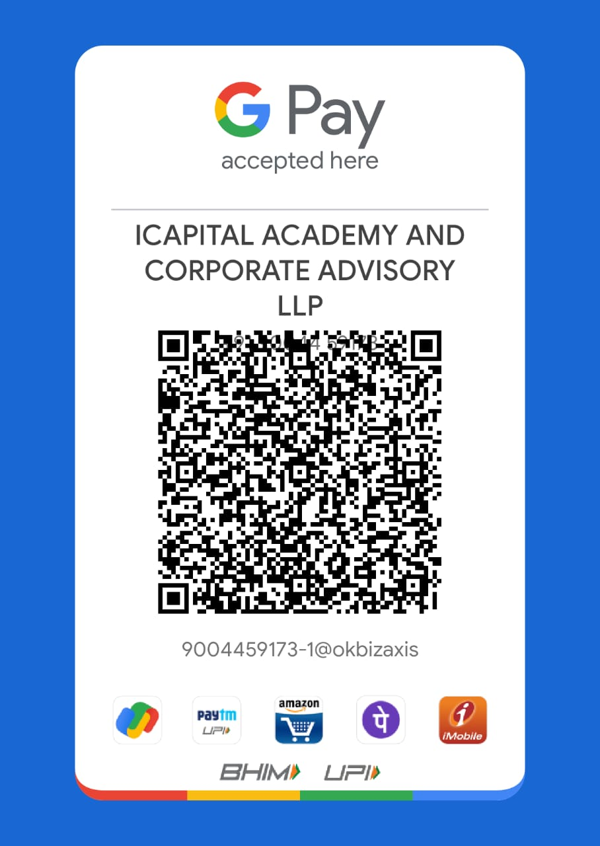
- Scan the QR Code:

(2) Transfer to the bank account:
ICAPITAL ACADEMY AND CORPORATE ADVISORY LLP
HDFC Current Account No. 50200054026244
IFSC- HDFC0000540
Branch: HDFC Bank, Sector-17, Vashi, Navi Mumbai
Connect With Us:
You Tube: https://www.youtube.com/@analystamit/videos
WhatsApp Channel: https://whatsapp.com/channel/0029Va4oQNcChq6G4BVV0y2q
Telegram Group: https://t.me/+7UyOIU8CRXs4MDdl
Telegram Channel: https://t.me/icapitalindia
Facebook Page: https://www.facebook.com/profile.php?id=100054381286073
X : https://x.com/Analystamit
LinkedIn: https://www.linkedin.com/in/analystamit/

Refund Policy
- Registration Fees paid by the candidate shall not be refunded under any circumstances after the classes have commenced.
- In case the registered candidate wishes to cancel the registration for the program, the candidate shall intimate ICAPITAL Academy via a written request or Email within 3 working days prior to the commencement of the program. Once the request has been approved by ICAPITAL Academy the candidate will be refunded 90% of the total course fees paid for the respective program.
- ^ ICAPITAL Academy reserves the right to change or modify the class date/ time due to certain exigencies.
Disclaimer
The content provided in this program/course is for educational and informational purposes only. ICAPITAL Academy & Corporate Advisory LLP does not provide financial, legal, or investment advice. Participants are encouraged to consult qualified financial advisors before making any investment decisions.
While all reasonable efforts have been made to ensure accuracy and completeness of the material, ICAPITAL Academy does not guarantee or warrant the reliability, accuracy, or completeness of the information presented. The program/course does not ensure success in examinations, certifications, or job placement.
The financial markets are subject to risks, and past performance is not indicative of future results. Participants are responsible for their own investment and financial decisions.

Terms & Conditions
- Enrollment and Fees
  - Enrollment is confirmed only upon receipt of the full course fee.
  - The course fee is non-refundable under any circumstances, except where explicitly stated.
  - NISM certification examination registration fees are not included in the course fee.
- Course Access
  - Access to course materials (PPTs, recordings, mock exams, etc.) is provided for the duration of the program or as specified by ICAPITAL Academy.
  - Unauthorized sharing, reproduction, or distribution of course materials is strictly prohibited.
- Participation
  - Participants must attend sessions regularly and adhere to the schedule.
  - ICAPITAL Academy reserves the right to reschedule or cancel sessions with prior notice.
- Certification
  - Completion of this program/course does not guarantee passing the NISM certification exam. Participants must register independently for the exam through NISM.
- Liability
  - ICAPITAL Academy is not liable for any direct, indirect, or incidental loss or damage resulting from reliance on the course material or participation in the program.
  - Participants acknowledge that the financial markets involve risks, and they are solely responsible for their investment decisions.
- Code of Conduct
  - Participants are expected to maintain a professional demeanor during sessions. Any disruptive behavior may result in removal from the program without refund.
- Amendments
  - ICAPITAL Academy reserves the right to update or modify the terms and conditions at any time. Participants will be notified of such changes.

